UNIVERSAL ORLANDO U-SELECT THEME PARK ADMISSION TICKETS DEFINITIONS/TERMS

NON-RESIDENT Tickets:

1-5 Day: 2 Park Base Ticket
The Multi-Day Base Ticket entitles one guest admission to ONE UO theme park per day, Universal Studios or Islands of Adventure. Ticket is valid for the amount of days purchased during a fourteen consecutive calendar day period which includes the first day any portion of the ticket is used. Visits to both parks in one day are not allowed.

1-5 Day: Park to Park Access
The Park to Park Access option entitles one guest admission to BOTH UO theme parks, Universal Studios and Islands of Adventure on the same day for the duration of the ticket. Park to Park tickets allows access to select club venues in Universal CityWalk® on all days.

3 Park Ticket
The 3-Park Ticket entitles one guest admission to Universal Studios Florida®, Universal’s Islands of Adventure®, and Universal’s Volcano Bay® water park. Base and Park to Park options are available.

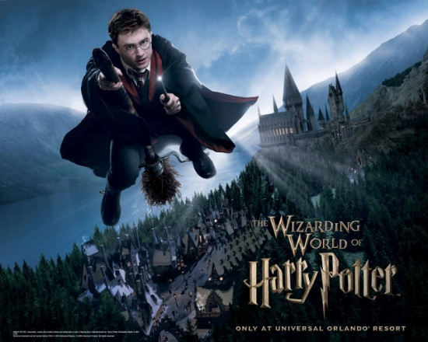

Your MWR ITT Office has numerous discounted hotels in the Orlando/Kissimmee area. We also book the on-site and partner Universal hotels as well.

FYI: You will be required to have the Park to Park ticket to ride the Hogwarts Express.

******UPDATED 03-02-2021******

Universal Studios Orlando

Ticket Price Sheet

Date of publication

Navy Community Recreation
Tickets & Travel Office
Phone: 439 – 3531/4206

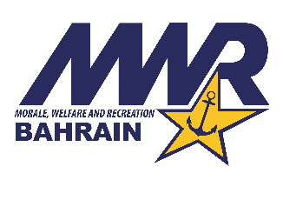
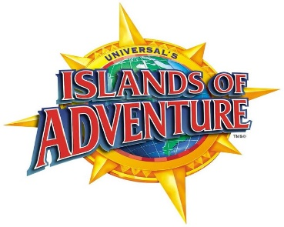
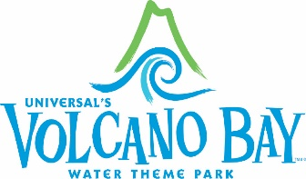

All prices/tickets subject to change
No Refunds or exchanges

2 PARK TICKETS
Universal Studios & Islands of Adventure

3 PARK TICKETS
Description | Gate Price | MWR Price
1 Day Base Anytime Adult | $154.43 | $153.00
1 Day Base Anytime Child (3 – 9) | $149.10 | $147.75
1 Day Park to Park Anytime Adult | $213.00 | $200.00
1 Day Park to Park Anytime Child (3 – 9) | $207.68 | $195.00
2 Day Base Adult | $288.60 | $266.50
2 Day Base Child (3 – 9) | $277.95 | $256.75
2 Day Park to Park Adult | $352.50 | $301.50
2 Day Park to Park Child (3 – 9) | $341.85 | $292.25
3 Day Base Adult | $328.01 | $282.25
3 Day Base Child (3 – 9) | $317.36 | $272.50
3 Day Park to Park Adult | $391.91 | $316.00
3 Day Park to Park Child (3 – 9) | $381.26 | $307.00
4 Day Base Adult | $340.79 | $284.25
4 Day Base Child (3 – 9) | $330.14 | $274.75
4 Day Park to Park Adult | $410.01 | $329.50
4 Day Park to Park Child (3 – 9) | $399.36 | $320.50
5 Day Base Adult | $352.50 | $291.25
5 Day Base Child (3 – 9) | $341.85 | $281.75
5 Day Park to Park Adult | $427.05 | $341.75
5 Day Park to Park Child (3 – 9) | $416.40 | $332.75
Universal Studios, Islands of Adventure & Volcano Bay Water Park

Description | Gate Price | MWR Price
3 Park 3 Day Base Adult | $378.06 | $328.00
3 Park 3 Day Base Child (3 – 9) | $367.41 | $318.25
3 Park 4 Day Base Adult | $400.43 | $336.75
3 Park 4 Day Base Child (3 – 9) | $389.78 | $327.25
3 Park 5 Day Base Adult | $421.73 | $351.50
3 Park 5 Day Base Child (3 – 9) | $411.08 | $342.25
3 Park 2 Day Park to Park Adult | $402.56 | $344.75
3 Park 2 Day Park to Park Child (3 – 9) | $391.91 | $335.50
3 Park 3 Day Park to Park Adult | $441.96 | $358.50
3 Park 3 Day Park to Park Child (3 – 9) | $431.31 | $349.50
3 Park 4 Day Park to Park Adult | $469.65 | $379.75
3 Park 4 Day Park to Park Child (3 – 9) | $459.00 | $370.75
3 Park 5 Day Park to Park Adult | $496.28 | $399.75
3 Park 5 Day Park to Park Child (3 – 9) | $485.63 | $390.75

MILITARY PROMOTIONAL TICKETS
Valid Jan. 1 – Dec. 31 2021 limit of 6 per military ID. Available for purchase by Active Duty, Reservists, Retirees, Dependants, 100% Disabled Veterans and DoD Civilians only

Description | Gate Price | MWR Price
2 Park Military Freedom Pass Adult | $234.29 | $200.00
2 Park Military Freedom Pass Child (3-9) | $228.96 | $195.00
3 Park Military Freedom Pass Adult | $271.56 | $235.00
3 Park Military Freedom Pass Child (3-9) | $266.24 | $230.00

